CHAPTER 1—COVALENT BONDING AND SHAPES OF MOLECULES

MULTIPLE CHOICE

1. How many electrons can the shell with a principal quantum number of 1 hold?
a. | 1
b. | 2
c. | 4
d. | 8

ANS: B

2. How many electrons can the shell with a principal quantum number of 2 hold?
a. | 1
b. | 2
c. | 4
d. | 8

ANS: D

3. What is the ground-state electronic configuration of a nitrogen atom (nitrogen: atomic number 7)?
a. | 1s²2s¹2p⁴
b. | 1s²2s²2p³
c. | 1s¹2s¹2p⁵
d. | 1s²2s²2p²

ANS: B

4. What is the ground-state electronic configuration of a fluorine atom (fluorine: atomic number 9)?
a. | 1s¹2s¹2p⁷
b. | 1s²2s²2p⁵
c. | 1s²2s²2p⁶
d. | 1s⁰2s²2p⁷

ANS: B

5. What is the ground-state electronic configuration of a fluoride anion (fluorine: atomic number 9)?
a. | 1s²2s²2p²
b. | 1s²2s²2p⁵
c. | 1s²2s²2p⁶
d. | 1s²2s²2p⁷

ANS: C

6. What is the ground-state electronic configuration of a sodium cation (sodium: atomic number 11)?
a. | 1s²2s²2p⁶3s¹
b. | 1s²2s²2p⁵3s¹
c. | 1s²2s²2p⁶
d. | 1s²2s²2p⁶3s²

ANS: C

7. Which of the following species has an atom that has an unfilled valence shell of electrons?
a. | molecular hydrogen, H₂
b. | hydroxide anion, HO⁻
c. | boron trifluoride, BF₃
d. | water, H₂O

ANS: C

8. Which of the following species has an atom that has an unfilled valence shell of electrons?
a. | molecular bromine, Br₂
b. | fluoride anion, F⁻
c. | ammonia, NH₃
d. | aluminum trichloride, AlCl₃

ANS: D

9. Which of the following species possesses a formal charge?
a. | BH₃
b. | BH₄
c. | CCl₄
d. | H₂S

ANS: B

10. Which of the following species possesses a formal charge?
a. | CCl₄
b. | SiCl₄
c. | AlCl₄
d. | PCl₃

ANS: C

11. Which of the following compounds is an aldehyde?
a. | CH₃CH₂CH₂COOH
b. | CH₃CH₂CHO
c. | CH₃CH₂CH₂OH
d. | CH₃CH₂COCH₃

ANS: B

12. Which of the following compounds is an alcohol?
a. | CH₃CH₂COOH
b. | CH₃CH₂OCH₃
c. | CH₃CH₂CH₂OH
d. | CH₃CH₂CHO

ANS: C

13. Which of the following compounds is a carboxylic acid?
a. | CH₃CH₂COOH
b. | CH₃CH₂OCH₃
c. | CH₃CH₂CH₂OH
d. | CH₃CH₂CHO

ANS: A

14. Which of the following compounds is a ketone?
a. | CH₃CH₂COOH
b. | CH₃CH₂CHO
c. | CH₃CH₂CH₂OH
d. | CH₃COCH₃

ANS: D

15. Which of the following compounds is a ketone?
a. | CH₃CH₂COOH
b. | CH₃CH₂CHO
c. | CH₃CH₂CH₂OH
d. | CH₃COCH₃

ANS: D

16. Which of the following compounds is a carboxylic ester?
a. | CH₃CH₂COOH
b. | CH₃CH₂OCH₃
c. | CH₃CH₂COOCH₃
d. | CH₃CH₂COCH₃

ANS: C

17. Which of the following is a tertiary alcohol?
a. | CH₃CH₂OCH₃
b. | (CH₃)₃COH
c. | (CH₃)₂CHOH
d. | CH₃CH₂CH₂OH

ANS: B

18. Which of the following is a tertiary amine?
a. | CH₃CH₂N(CH₃)₂
b. | (CH₃)₃CNH₂
c. | CH₃CH₂NHCH₃
d. | CH₃CH₂NHCH(CH₃)₂

ANS: A

19. Which of the following is a primary amine?
a. | CH₃CH₂NHCH₃
b. | CH₃CH₂NHCH(CH₃)₂
c. | CH₃CH₂N(CH₃)₂
d. | (CH₃)₃CNH₂

ANS: D

20. Which of the following is trigonal planar?
a. | boron trifluoride, BF₃
b. | methyl anion, CH₃⁻
c. | methane, CH₄
d. | ammonia, NH₃

ANS: A

21. Which of the following molecules is not linear?
a. | H₂O
b. | CO₂
c. | HC≡CH
d. | Cl₂

ANS: A

22. What is the approximate value of the HCH bond angles in methane, CH₄?
a. | 90°
b. | 109°
c. | 120°
d. | 180°

ANS: B

23. What is the approximate CCC bond angle in propene, CH₃CH=CH₂?
a. | 90°
b. | 109°
c. | 120°
d. | 180°

ANS: C

24. What is the approximate CCC bond angle in propyne, HCCCH₃?
a. | 90°
b. | 109°
c. | 120°
d. | 180°

ANS: D

25. What is the approximate HCO bond angle in formaldehyde, H₂C=O?
a. | 90°
b. | 109°
c. | 120°
d. | 180°

ANS: C

26. Which of the following elements has the highest electronegativity?
a. | N
b. | C
c. | O
d. | S

ANS: C

27. Which of the following elements has the highest electronegativity?
a. | C
b. | P
c. | Si
d. | Cl

ANS: D
28. Which of the following bonds is the most polar?
a. | F−F
b. | H−F
c. | C−H
d. | C−Si

ANS: B

29. Which of the following bonds is the most polar?
a. | O−H
b. | C−H
c. | C−C
d. | H−H

ANS: A

30. Which of the following bonds is a polar covalent bond?
a. | Na−F
b. | C−H
c. | C−O
d. | Cl−Cl

ANS: C

31. Which of the following bonds is a polar covalent bond?
a. | Na−Cl
b. | C−Cl
c. | C−H
d. | Cl−Cl

ANS: B

32. Which of the following is an ionic bond?
a. | Br−Br
b. | C−Cl
c. | C−S
d. | Na−O

ANS: D

33. Which of the following is an ionic bond?
a. | F−F
b. | C−H
c. | Li−O
d. | C−N

ANS: C

34. Which of the following bonds has the smallest dipole moment?
a. | C−N
b. | C−O
c. | C−F
d. | O−H

ANS: A

35. Which of the following bonds has the smallest dipole moment?
a. | Li−Cl
b. | C−H
c. | O−H
d. | H−Cl

ANS: B

36. Which of the following molecules has a molecular dipole moment?

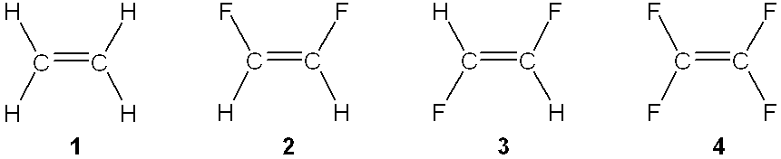

a. | 1
b. | 2
c. | 3
d. | 4

ANS: B

37. Which of the following molecules has a molecular dipole moment?

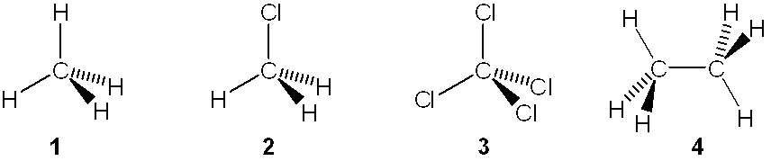

a. | 1
b. | 2
c. | 3
d. | 4

ANS: B

38. Which of the following molecules has a molecular dipole moment?
a. | CO₂
b. | BF₃
c. | NH₃
d. | CH₄

ANS: C

39. Which of the following molecules has a molecular dipole moment?
a. | H₂O
b. | CO₂
c. | HC≡CH
d. | Cl₂

ANS: A
40. Which of the following best represents the shape of the 2s atomic orbital of carbon?

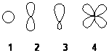

a. | 1
b. | 2
c. | 3
d. | 4

ANS: A

41. Which of the following best represents the shape of a 2p atomic orbital of carbon?

a. | 1
b. | 2
c. | 3
d. | 4

ANS: B

42. Which of the following best represents an sp² hybridized atomic orbital of carbon which overlaps with the 1s atomic orbital of hydrogen to form a C−H σ bonding molecular orbital in ethene, H₂C=CH₂

a. | 1
b. | 2
c. | 3
d. | 4

ANS: C

43. Which of the following best represents an sp³ hybridized atomic orbital containing the lone pair of electrons of ammonia, NH₃?

a. | 1
b. | 2
c. | 3
d. | 4

ANS: C

44. Which atomic orbitals overlap to form the C=O bond of acetone, (CH₃)₂C=O?
a. | C 2sp³ + O 2sp²
b. | C 2sp² + O 2p
c. | C 2sp² + O 2sp²
d. | C 2sp³ + O 2sp

ANS: C

45. Which atomic orbitals overlap to form the CO bond of dimethyl ether, (CH₃)₂O?
a. | C 2sp³ + O 2sp²
b. | C 2sp² + O 2p
c. | C 2sp² + O 2sp²
d. | C 2sp³ + O 2sp³

ANS: D

46. What is the approximate value of the length of the C=C bond in ethane, CH₂=CH₂?
a. | 121 pm
b. | 134 pm
c. | 142 pm
d. | 154 pm

ANS: B

47. What is the approximate value of the length of the CC bond in ethyne, HCCH?
a. | 121 pm
b. | 134 pm
c. | 142 pm
d. | 154 pm

ANS: A

48. Which of the following statements is not true regarding resonance structures?
a. | All resonance structures must have the same number of electrons
b. | Each atom in all of the resonance structures must have a complete shell of valence electrons
c. | All resonance structures must have the same arrangement of atoms
d. | All resonance structures must be valid Lewis structures

ANS: B

49. Which of the following statements is not true regarding resonance structures?
a. | Each resonance structure is in rapid equilibrium with all of the other structures
b. | The resonance structures may have different energies
c. | All resonance structures must have the same arrangement of atoms
d. | All resonance structures must have the same number of electrons

ANS: A

50. Which of the following statements is not true about the carbonate anion, CO₃^{2}?
a. | All of the oxygen atoms bear the same amount of charge
b. | All of the carbon-oxygen bonds are the same length
c. | The carbon atom bears the negative charge
d. | It is basic

ANS: C

51. Which of the following statements is not true about the acetate anion, CH₃CO₂?
a. | The oxygen atoms bear the same amount of charge
b. | The two carbon-oxygen bonds are the same length
c. | The carbon atom bears the negative charge
d. | It is basic

ANS: C

52. Rank the following in order of decreasing importance as a contributing resonance structure to the molecular structure of acetone, CH₃COCH₃ (more important > less important)

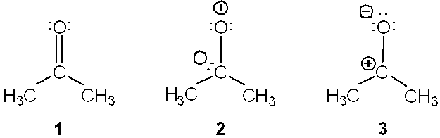

a. | 1 > 2 > 3
b. | 1 > 3 > 2
c. | 2 > 1 > 3
d. | 3 > 1 > 2

ANS: B

53. Which of the following resonance structures is the least important contributor to the resonance hybrid of the acetate anion, CH₃COO⁻?

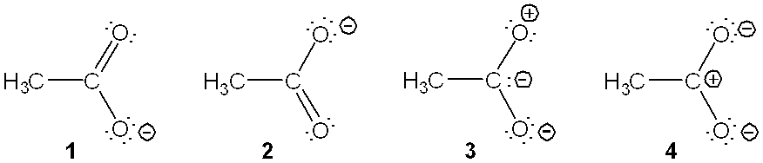

a. | 1
b. | 2
c. | 3
d. | 4

ANS: C

54. How many electrons are there in the valence shell of the carbon atom of a methyl cation, CH₃⁺?
a. | 4
b. | 5
c. | 6
d. | 7

ANS: C

55. How many electrons are there in the valence shell of the carbon atom of the methyl anion, CH₃?
a. | 2
b. | 4
c. | 6
d. | 8

ANS: D

56. How many electrons are there in the valence shell of the oxygen atom of water?
a. | 2
b. | 4
c. | 6
d. | 8

ANS: D

57. How many electrons are there in the valence shell of the nitrogen atom of ammonia?
a. | 4
b. | 5
c. | 6
d. | 8

ANS: D

58. What is the approximate value of the HCH bond angles in a methyl cation, CH₃⁺?
a. | 90°
b. | 109°
c. | 120°
d. | 180°

ANS: C

59. What is the approximate value of the HCH bond angles in a methyl anion, CH₃?
a. | 90°
b. | 109°
c. | 120°
d. | 180°

ANS: B

60. Which atomic orbitals overlap to form the carbon-hydrogen  bonding molecular orbitals of ethane, CH₃CH₃?
a. | C2p + H1s
b. | C2sp + H1s
c. | C2sp² + H1s
d. | C2sp³ + H1s

ANS: D

61. Which atomic orbitals overlap to form the carbon-hydrogen  bonding molecular orbitals of ethene, H₂C=CH₂?
a. | C2p + H1s
b. | C2sp + H1s
c. | C2sp² + H1s
d. | C2sp³ + H1s

ANS: C

62. Which atomic orbitals overlap to form the carbon-carbon  and  bonding molecular orbitals of ethene, H₂C=CH₂?
a. | C2sp³ + C2sp³, and C2p + C2p
b. | C2sp² + C2sp², and C2sp² + C2sp²
c. | C2sp² + C2sp², and C2p + C2p
d. | C2sp³ + C2sp³, and C2sp² + C2sp²

ANS: C

63. Which atomic orbitals overlap to form the carbon-hydrogen  bonding molecular orbitals of ethyne, HCCH?
a. | C2p + H1s
b. | C2sp + H1s
c. | C2sp² + H1s
d. | C2sp³ + H1s

ANS: B

64. Which atomic orbitals overlap to form the carbon-carbon  molecular bonding orbital of ethyne, HCCH?
a. | C2p + C2p
b. | C2sp + C2sp
c. | C2sp² + C2sp²
d. | C2sp³ + C2sp³

ANS: B

65. Which of the following is a primary (1°) alcohol?

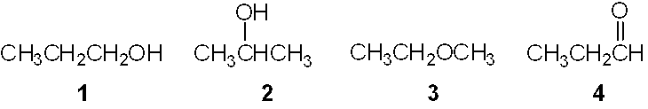

a. | 1
b. | 2
c. | 3
d. | 4

ANS: A

66. Which of the following is a tertiary (3°) alcohol?

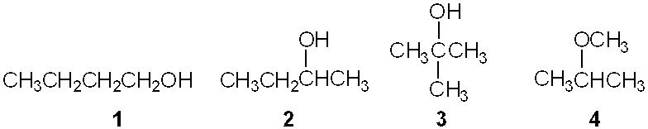
a. | 1
b. | 2
c. | 3
d. | 4

ANS: C

67. Which of the following is a primary (1°) amine?

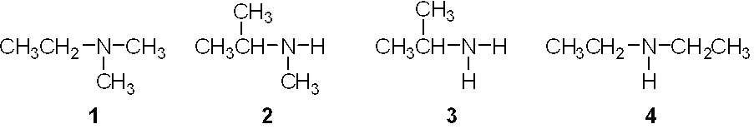

a. | 1
b. | 2
c. | 3
d. | 4

ANS: C

68. Which of the following is a secondary (2°) amine?

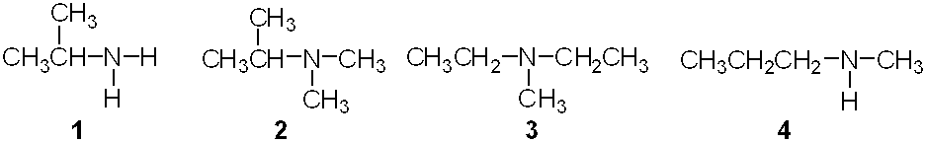

a. | 1
b. | 2
c. | 3
d. | 4

ANS: D

69. Which of the following is an carboxylic ester?

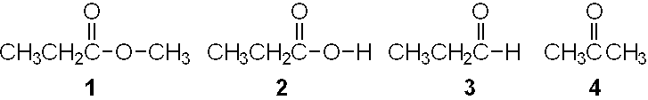

a. | 1
b. | 2
c. | 3
d. | 4

ANS: A
70. What is the approximate strength of the CC bond of ethane?
a. | 376 kJ/mol (90 kcal./mol)
b. | 422 kJ/mol (101 kcal./mol)
c. | 556 kJ/mol (133 kcal./mol)
d. | 727 kJ/mol (174 kcal./mol)

ANS: A

71. Which of the circled bonds is the strongest?

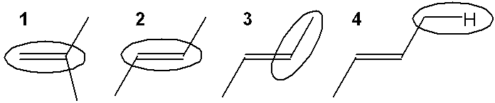

a. | 1
b. | 2
c. | 3
d. | 4

ANS: A

72. Which of the following resonance structures makes the largest contribution to the structure of [H₂CCHO] ⁻?

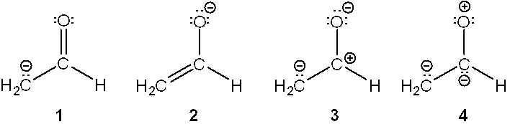

a. | 1
b. | 2
c. | 3
d. | 4

ANS: B

73. Which of the following shows curved arrows that correctly accounts for the differences between the two structures?

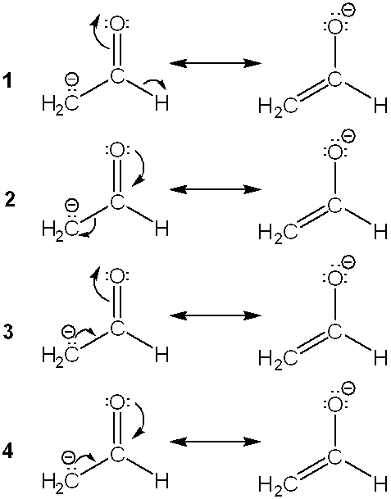

a. | 1
b. | 2
c. | 3
d. | 4

ANS: C

74. Which of the following statements is not true?
a. | The sp³C−H bond of an alkane is weaker than the spC−H bond of an alkyne.
b. | The carbon-carbon triple bond of an alkyne is shorter than the carbon-carbon bond of alkenes.
c. | The carbon-carbon triple bond of an alkene is exactly three times as strong as a carbon-carbon single bond of an alkane.
d. | The sp³C−H bond of an alkane is longer than the spC−H bond of an alkyne.

ANS: C

75. Which of the following is/are tetrahedral?

1. | methane, CH₄
2. | methyl carbocation, CH₃⁺
3. | methyl carbanion, CH₃⁻
4. | methyl radical, CH₃⋅

a. | only 1 and 2
b. | only 1 and 3
c. | only 1 and 4
d. | only 2 and 3

ANS: B

TRUE/FALSE

1. The following two structural formulas represent isomers.
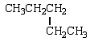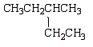

ANS: F

2. Consider the following structural formula.
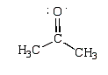
The following is a resonance structure.
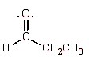

ANS: F

3. Overlap of the two atomic orbitals as shown could result in the formation of a π bond.
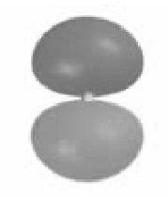

ANS: T

4. Consider the following molecular model.

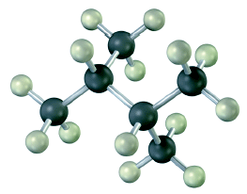

The condensed structural formula would be
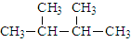

ANS: T

5. The hybridization on the numbered carbon atoms in the following compound would be Carbon 1 sp³ and Carbon 2 sp².

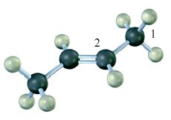

ANS: T

6. There are eight valence in a methyl anion, CH₃⁻.

ANS: T

7. The following species forms during an organic reaction.
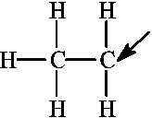
The formal charge on the carbon atom indicated by the arrow is +1.

ANS: T

8. In drawing the Lewis structure for an organic compound, the carbon atoms should always be shown with eight total electrons.

ANS: T

9. Consider the structure of urea given below.
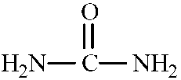
To complete the Lewis structure, six nonbonding electrons should be added, two to each of the nitrogen atoms and two to the oxygen atom.

ANS: F

10. The curved arrows in the resonance structure for the acetate ion shown below
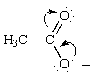
indicate the following alternative resonance structure for the acetate ion.
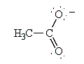

ANS: T

11. The maximum number of electrons that a molecular orbital can contain is four.

ANS: F

12. The following molecules all contain the same functional group except 2.

CH₃OH | CH₃OCH₃ | CH₃CH₂OH | CH₃CH(OH)CH₃
1 | 2 | 3 | 4

ANS: T

13. The percent s character in an sp² hybridized orbital is approximately 33%.

ANS: T

14. The formal charges in the complex should below are 0 on each H, –1 on N, and +1 on B.
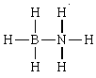

ANS: F

15. The most electronegative elements in the periodic table are generally found toward the right in a horizontal row and toward the top in a column.

ANS: T

COMPLETION

1. Different compounds with the same molecular formula are called __________.

ANS: isomers

2. The formal charge on carbon in carbon monoxide is______.

ANS: minus one -1

3. The approximate H–C–H bond angle in methane is ______°.

ANS: 109.5 109

4. The following molecule contains an _____________functional group.
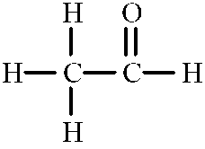

ANS: aldehyde

5. The following molecule is classified as a __________amine.

ANS: secondary 2°

PROBLEM

1. Provide a neatly drawn figure to show the atomic orbitals that overlap to form each of the bonds in water (H₂O) and which contain the lone pair of electrons. Label each orbital with its hybridization.

ANS:
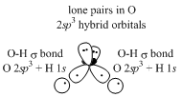

2. Provide a neatly drawn figure to show the atomic orbitals that overlap to form each of the bonds in ammonia (NH₃) and which contain the lone pair of electrons. Label each orbital with its hybridization.

ANS:
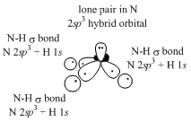

3. Provide a neatly drawn figure to show the atomic orbitals that overlap to form each of the bonds in ethene (ethylene, H₂C=CH₂). Label each bond (e.g., C–H σ bond) and indicate which atomic orbitals contribute to this bond (e.g., C 2sp³ + H 1s).

ANS:
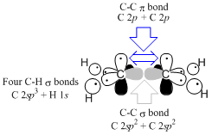

4. Provide a neatly drawn figure to show the atomic orbitals that overlap to form each of the bonds in ethyne (acetylene, HC≡CH). Label each bond (e.g., C–H σ bond) and indicate which atomic orbitals contribute to this bond (e.g., C 2sp³ + H 1s).

ANS:
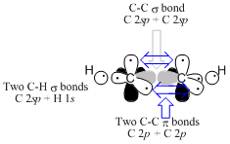

5. Draw bond-line structures of all of the alkanes that have the formula C₅H₁₂.

ANS:
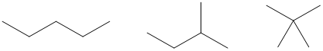

6. Draw bond-line structures of all of the alcohols that have the formula C₄H₁₀O.

ANS:
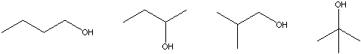

7. Draw bond-line structures of all of the aldehydes that have the formula C₅H₁₀O.

ANS:
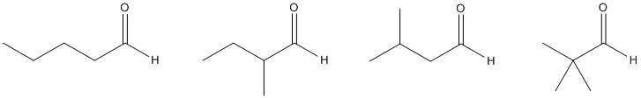

8. Draw bond-line structures of all of the ketones that have the formula C₅H₁₀O.

ANS:
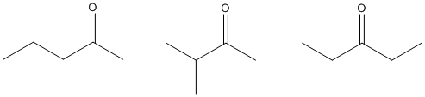

9. Draw bond-line structures of all of the primary (1°) alcohols that have the formula C₅H₁₂O.

ANS:
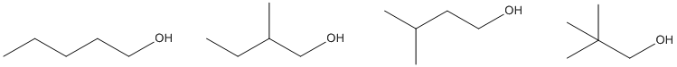

10. Draw bond-line structures of all of the tertiary (3°) alcohols that have the formula C₆H₁₄O.

ANS:
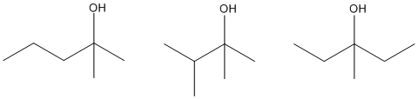

11. Draw bond-line structures of all of the secondary (2°) amines that have the formula C₄H₉N.

ANS:
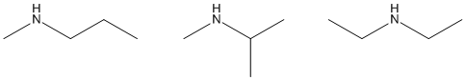

12. Draw bond-line structures of all of the tertiary (3°) amines that have the formula C₅H₁₁N.

ANS:
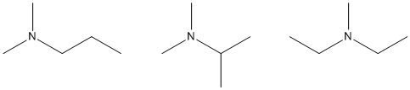

13. Circle all of the sp² hybridized atoms in the following molecular structure.
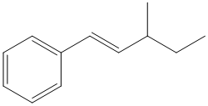

ANS:
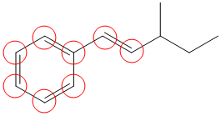

14. Circle all of the sp hybridized atoms in the following molecular structure.
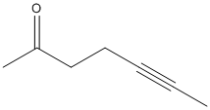

ANS:
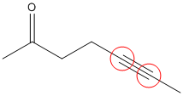

15. Convert the following structure into a bond-line drawing.
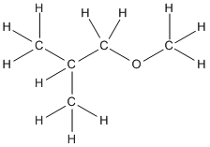

ANS:
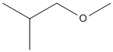

16. Convert the following structure into a bond-line drawing.
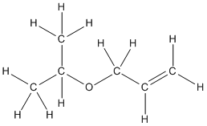

ANS:
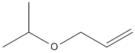

17. What is the molecular formula of Ritalin, shown below?
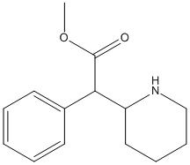

ANS: C₁₄H₁₉NO₂

18. What is the molecular formula of aspartame, shown below?
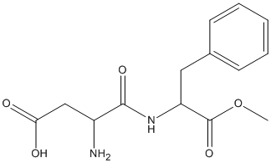

ANS: C₁₄H₁₈N₂O₅

19. Circle and name the functional groups in the following molecule.
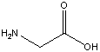

ANS:
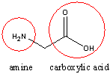

20. Circle and name the functional groups in the following molecule.
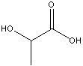

ANS:
